2023 LADIES SINGLES PROVINCIAL CHAMPION

RENEE LAFRAMBOISE – NICKEL DISTRICT
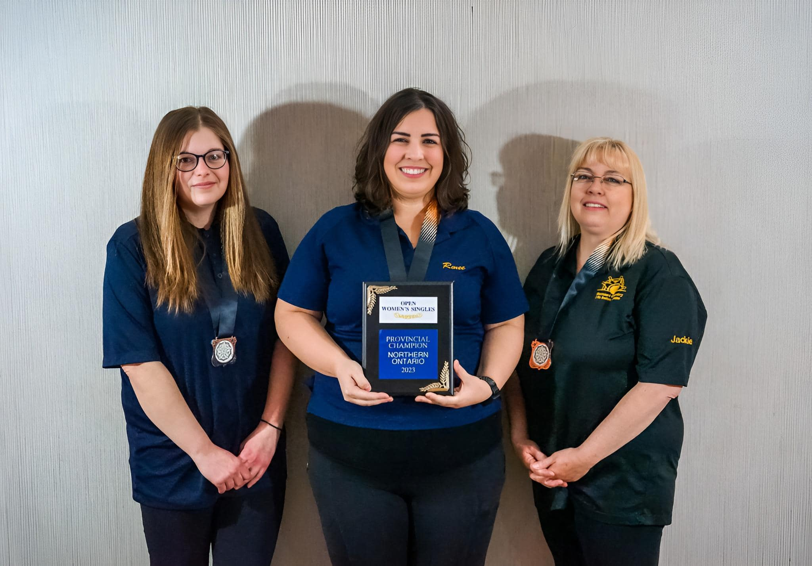
Silver Medallist – Sarah Pearse | Gold Medallist – Renee Laframboise | Bronze Medallist – Jackie Miner
NICKEL DISTRICT | NICKEL DISTRICT | SUNSET COUNTRY

PREVIOUS LADIES’ SINGLES PROVINCIAL CHAMPIONS
1979 | Gail Wiseman | NICKEL DISTRICT
1980 | Germaine Paquette | NICKEL DISTRICT
1981 | Wendy MacKenzie | GATEWAY
1982 | Mary Nicholls | THUNDER BAY
1983 | Carole Kolisnek | NICKEL DISTRICT
1984 | Hazel Eccelston | THUNDER BAY
1985 | Darlene Krauss | NICKEL DISTRICT
1986 | Laura Mitchell | NICKEL DISTRICT | NATIONAL GOLD MEDALLIST AND ALL-STAR
1987 | Denise Cardinal | CAMBRIAN NORTH
1988 | Linda Michano | THUNDER BAY | NATIONAL BRONZE MEDALLIST
1989 | Paula Taus | NICKEL DISTRICT
1990 | Cathy Davidson | NICKEL DISTRICT | NATIONAL SILVER MEDALLIST
1991 | Natalie Gamache | GOLD BELT
1992 | Sherry Jolette | NICKEL DISTRICT
1993 | Sharon Zaborniak | THUNDER BAY
1994 | Cathy Davidson | CAMBRIAN NORTH
1995 | Natalie Bacvar | GOLD BELT
1996 | Cathy Davidson | CAMBRIAN NORTH
1997 | Cathy Davidson | CAMBRIAN NORTH
1998 | Barbra McLachlan | CAMBRIAN NORTH
1999 | Cathy Davidson | CAMBRIAN NORTH
2000 | Lynn Gosselin | NICKEL DISTRICT
2001 | Barbra McLachlan | CAMBRIAN NORTH | NATIONAL BRONZE MEDALLIST AND ALL-STAR
2002 | Barbra McLachlan | CAMBRIAN NORTH | NATIONAL BRONZE MEDALLIST
2003 | Marg Attridge | GATEWAY
2004 | Lynn Gosselin | NICKEL DISTRICT
2005 | Yvette MacLellan | CAMBRIAN NORTH
2006 | Shelley Petsnick | SUNSET COUNTRY
2007 | Kim Goedhuis¹ | CAMBRIAN NORTH
2008 | Yvette MacLellan | CAMBRIAN NORTH
2009 | Tammy Walchuk | NORTH OF SUPERIOR
2010 | Cindy Lalonde | NICKEL DISTRICT
2011 | Yvette MacLellan | CAMBRIAN NORTH | NATIONAL BRONZE MEDALLIST
2012 | Tammy Walchuk | THUNDER BAY
2013 | Jeannette Gobeil | CAMBRIAN NORTH
2014 | Katie Bonnie | THUNDER BAY
2015 | Katie Bonnie | THUNDER BAY | NATIONAL GOLD MEDALLIST AND ALL-STAR
2016 | Renee Laframboise | NICKEL DISTRICT
2017 | Sam Sitar | THUNDER BAY
2018 | Renee Laframboise | NICKEL DISTRICT
2019 | Sam Sitar | THUNDER BAY | NATIONAL SILVER MEDALLIST
2022 | Katie Bonnie | THUNDER BAY
2023 | Renee Laframboise | NICKEL DISTRICT | NATIONAL GOLD MEDALLIST AND ALL-STAR
1 – Replaced by Yvette MacLellan at Nationals who won a bronze medal

LADIES SINGLES - RECORD SCORES
HIGH SINGLE | Cathy Davidson | CAMBRIAN NORTH | 1996 | 401
HIGH FIVE | Darlene Krauss | NICKEL DISTRICT | 1985 | 1560
HIGH TEN | Barbra McLachlan | CAMBRIAN NORTH | 2001 | 2916

TRIBUTE TO THE 2023 C5PBA NATIONAL OPEN LADIES SINGLES CHAMPION – RENEE LAFRAMBOISE
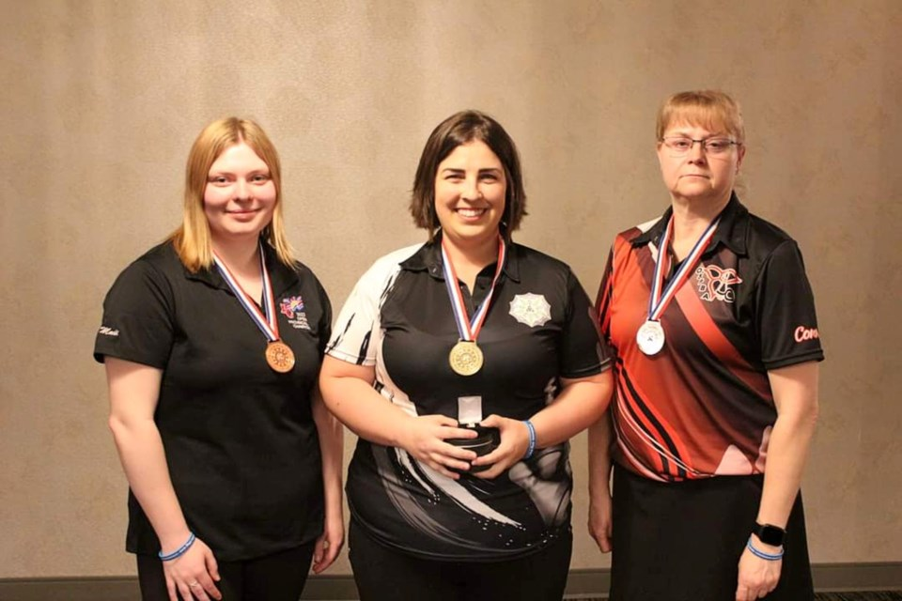
Bronze Medallist – Madison Richter | Gold Medallist – Renee Laframboise | Silver Medallist – Connie Ward
BRITISH COLUMBIA | NORTHERN ONTARIO | ONTARIO

At the 2023 C5PBA Nationals in Edmonton, Renee absolutely dominated the ladies singles field. After averaging a stellar 278 for the first 14 games and having the lead, she shifted her bowling into another gear in the last seven games by throwing four games over 300 and averaging 303 for the day. She ended the qualifying round as the top seed with a national record average of 286.7, 477 pins ahead of her nearest opponent. She faced off against Connie Ward of Ontario (the 2007 champion) in the gold medal match and defeated her 326-262, winning the national title. She joins Laura Mitchell and Katie Bonnie as C5PBA National Open Ladies Singles Champions from Northern Ontario.

WAY TO GO, RENEE! YOU MADE NORTHERN ONTARIO PROUD WITH YOUR EXCELLENT PERFORMANCE!

