2023 LADIES TEAM PROVINCIAL CHAMPIONS

NICKEL DISTRICT
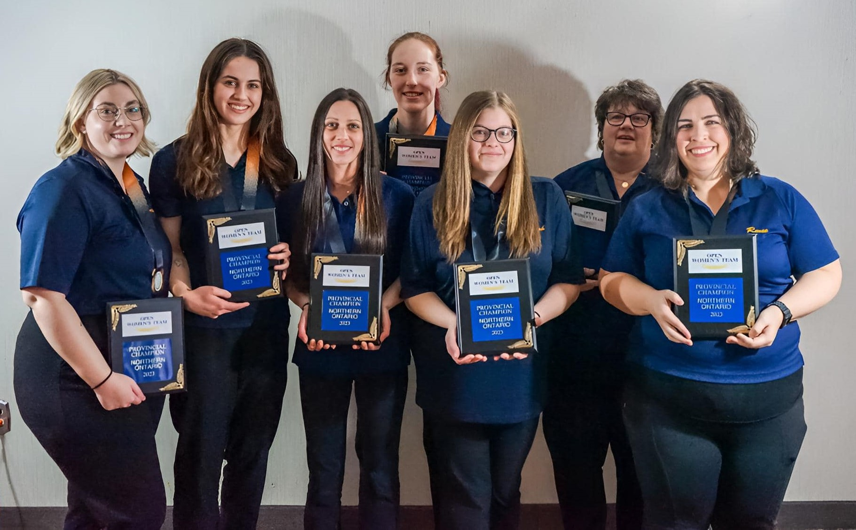
From left-to-right: Brittney Boileau, Isabelle Rodrigue, Melissa Boutin, Tessa Cain, Sarah Pearse, Elaine Laframboise (coach), Renee Laframboise

At the 2023 C5PBA Nationals in Edmonton, the ladies team finished second overall in the 16-game qualifying round, averaging 233 as a team and finished just one point behind first place Alberta. Unfortunately, the team lost the semi-final to Quebec 8-0 (1214-1031) to take the bronze medal. Renee led the team with a 272.38 average and was named to the all-star team.

PREVIOUS LADIES TEAM PROVINCIAL CHAMPIONS
1979 – NICKEL DISTRICT
Mailis Latava, Laura Mitchell, Gail Wiseman, Vi Roy, Bea Beaupre, Beverley Rollins, Bill Mitchell (coach)
1980 – NICKEL DISTRICT
Mailis Latava, Germaine Paquette, Gail Wiseman, Norma Cusson, Vi Roy, Laura Mitchell*, Bill Mitchell (coach)
1981 – NICKEL DISTRICT – NATIONAL SILVER MEDALLISTS
Norma Cusson, Sue Nelsons, Dorothy Malott, Claire Fulin, Mailis Latava, Carole Kolisnek, Bill Mitchell (coach)
1982 – THUNDER BAY
Hazel Eccleston, Mary Nicholls, Ada Becotte, Donna Hryenchuk, Vicki Slater, Judy Vilella, Alex Jacobs (coach)
1983 – NICKEL DISTRICT
Carole Kolisnek, Kim Tessier, Gail Wiseman, Laura Mitchell, Elfie Kreko, Sue Nelsons, Bill Mitchell (coach)
1984 – THUNDER BAY
Brenda Hummel, Hazel Eccleston, Pat Maguire, Vicki Slater, Mary Nicholls, Lucille Harris, Frank Massaro (coach)
1985 – NICKEL DISTRICT
Darlene Krauss, Pete Lalonde, Norma Cusson, Laura Mitchell, Paula Taus, Pauline Lacelle, Bill Mitchell (coach)
1986 – THUNDER BAY
Lois Buckley, Hazel Eccleston, Wendy Burla, Sherri Randle, Vicki Slater, Leila Oja, Frank Massaro (coach)
1987 – GATEWAY
Lise Allaire, Wendy MacKenzie, Linda St. Amand, Diane Desbois, Wannetta Beckett, Tina Lapensee, Reggie Lacroix (coach)
1988 – THUNDER BAY
Hazel Eccleston, Linda Michano, Sherri Randle, Eunice Hill, Lucille Ball, Selena Pelletier, Wayne Lemcke (coach)
1989 – NICKEL DISTRICT
Paula Taus, Lynn Brosseau, Denise Gross, Betty Burnside, Kathy Gervais, Darlene Krauss, Bill Mitchell (coach)
1990 – NICKEL DISTRICT
Cathy Davidson, Darlene Krauss, Lynn Brosseau, Kim Tessier, Denise Cardinal, Kathy Gervais, Jack Atkinson (coach)
1991 – NICKEL DISTRICT – NATIONAL BRONZE MEDALLISTS
Cathy Davidson, Paula Taus*, Lynn Brosseau, Darlene Krauss, Claudette Gadoury, Kathy Gervais, Graham Squirell (coach)
1992 – CAMBRIAN NORTH
Cathy Davidson, Yvette Schryer, Laura Mitchell, Milly Rothwell, Coco Lariviere, Joanne Kingston, Denise Gross (coach)
1993 – SUNSET COUNTRY
Shelley McGinn, Carol Peterson, Gwen Amorde, Maureen Redsky, Sheila Engel, Shirley Jensson, Toni Bale (coach)
1994 – CAMBRIAN NORTH
Coco Lariviere, Cathy Davidson, Sara Horner*, Doris Kirkey, Monique L’Heureux, Gisele Venne, Carmen Champagne (coach)
1995 – NICKEL DISTRICT
Sherry Jolette, Jeannine Caya, Sue Lacroix, Cynthia Lalonde, Carole Kolisnek, Lynn Meilleur, Ellen Leblanc (coach)
1996 – SUNSET COUNTRY
Maureen Desserre, Terry Delaronde, Tammy Fleischhaker, Janet Ellis, Shirley Jensson, Shelley McGinn, Sheila Engel (coach)
1997 – CAMBRIAN NORTH
Cathy Davidson, Doris Kirkey, Yvette Schryer, Chris Godin, Coco Lariviere, Deborah Freeland, Jerome Lesny (coach)
1998 – CAMBRIAN NORTH
Cathy Davidson, Barbra McLachlan*, Sue Paquet, Pamela Lepage, Yvette Schryer, Chris Godin, Gail Wiseman (coach)
1999 – CAMBRIAN NORTH – NATIONAL SILVER MEDALLISTS
Cathy Davidson, Pamela Lepage, Barbra McLachlan*, Doris Kirkey, Denise Blake, Chris Godin, Roger Cardinal (coach)
2000 – CAMBRIAN NORTH – NATIONAL GOLD MEDALLISTS
Barbra McLachlan*, Yvette MacLellan, Cathy Davidson, Denise Blake, Jennifer Raymond, Doris Kirkey, Coco Lariviere (coach)
2001 – CAMBRIAN NORTH
Barbra McLachlan*, Doris Kirkey, Pamela Lepage, Cathy Davidson, Yvette MacLellan, Chris Godin, Maurice Raymond (coach)
2002 – SUNSET COUNTRY
Krystyna Bednarski, Maureen Desserre, Shelley Petsnick, Tammy Woitowicz, Terri Hamilton, Carol Peterson, Terry Delaronde (coach)
PREVIOUS LADIES TEAM PROVINCIAL CHAMPIONS
2003 – CAMBRIAN NORTH
Barbra McLachlan*, Sue Lacroix, Doris Kirkey, Yvette MacLellan, Donna Stevens, Maureen McKay-Horner, Roger Cardinal (coach)
2004 – NICKEL DISTRICT
Lynn Gosselin, Kelly McNamara, Tara Robson, Cindy Lalonde, Shawna Gauthier, Paula McNamara, Barry Gagnon (coach)
2005 – CAMBRIAN NORTH
Yvette MacLellan, Doris Kirkey, Chris Godin, Johanne Roux, Denise Blake, Suzanne Paquet, Jerome Lesny (coach)
2006 – NICKEL DISTRICT
Lynn Gosselin, Tara Robson, Chantal Laframboise^{R}, Paula McNamara, Kelly McNamara, Maija Holla, Bill Mitchell (coach)
2007 – CAMBRIAN NORTH
Yvette MacLellan, Kim Goedhuis, Chris Godin, Jennifer Raymond, Jeannette Stevenson, Denise Blake, Jerome Lesny (coach)
2008 – CAMBRIAN NORTH
Yvette MacLellan, Tanya Binkley, Kim Goedhuis, Chris Godin, Jeannette Stevenson, Denise Blake, Jerome Lesny (coach)
2009 – CAMBRIAN NORTH
Yvette MacLellan, Shannon Swerdlyk, Kim Goedhuis, Paula McNamara, Doris Kirkey, Chris Godin, Jerome Lesny (coach)
2010 – NICKEL DISTRICT
Renee Laframboise, Cindy Lalonde, Kelly McNamara, Tara Robson, Tabera Kennedy, Chantal Laframboise, Bill Mitchell (coach)
2011 – NICKEL DISTRICT
Lynn Gosselin, Sarah Umakoshi, Renee Laframboise, Tara Robson, Paula McNamara, Cindy Lalonde, Ziggy Zaldiner (coach)
2012 – CAMBRIAN NORTH
Yvette MacLellan, Doris Kirkey, Kim Goedhuis, Chris Godin, Natalie Godin, Paula McNamara, Maureen McKay-Horner (coach)
2013 – CAMBRIAN NORTH
Yvette MacLellan, Jeannette Gobeil, Chris Godin, Kim Goedhuis, Natalie Godin, Paula McNamara, Lynn Imbeau (coach)
2014 – THUNDER BAY
Samantha Sitar, Katie Bonnie, Krysten Cripps, Amanda Nichols, Ashley Bjorklund, Kirstynn Taniwa, Brian Bonnie (coach)
2015 – CAMBRIAN NORTH
Yvette MacLellan, Natalie Godin, Chris Godin, Doris Kirkey, Jennifer Daw, Paula McNamara, Maureen McKay-Horner (coach)
2016 – THUNDER BAY – NATIONAL BRONZE MEDALLISTS
Katie Bonnie, Bailey Lachaine¹, Amanda Nichols, Alyssa Bonnie^{R}, Sam Sitar, Angela Begin, Brian Bonnie (coach)
2017 – THUNDER BAY – NATIONAL GOLD MEDALLISTS
Katie Bonnie, Alyssa Bonnie*, Sam Sitar, Devan Hook, Amanda Melanson, Ashley Bjorklund, Doug Glena (coach)
2018 – NICKEL DISTRICT
Renee Laframboise*, Ashley Tremblay, Shawna Ann Upson, Danica Lefebvre, Cindy Remmerswaal, Romona Stables, Elaine Laframboise (coach)
2019 – CAMBRIAN NORTH
Natalie Godin, Yvette MacLellan, Tania Philion, Chris Godin, Jennifer McLaughlin, Doris Kirkey, Jerome Lesny (coach)
2022 – THUNDER BAY – NATIONAL SILVER MEDALLISTS
Amanda Nichols, Sam Sitar*, Katie Bonnie, Michaela Turner, Alyssa Bonnie, Paige Hadley, Brian Bonnie (coach)
2023 – NICKEL DISTRICT – NATIONAL BRONZE MEDALLISTS
Renee Laframboise*, Isabelle Rodrigue, Sarah Pearse, Tessa Cain, Melissa Boutin, Brittney Boileau, Elaine Laframboise (coach)
* – National All-Star 1 – Replaced by Yvette MacLellan at Nationals R – National Rookie-Of-The-Year

LADIES TEAM – PROVINCIAL RECORD SCORES - INDIVIDUAL
HIGH SINGLE | Linda Michano | THUNDER BAY | 1995 | 410
HIGH FIFTEEN | Jeannette Stevenson | NORTH OF SUPERIOR | 2001 | 4191

LADIES TEAM – PROVINCIAL RECORD SCORES – TEAM
HIGH SINGLE | NICKEL DISTRICT | 1981 | 1442
HIGH FIFTEEN | NICKEL DISTRICT | 1990 | 18372
HIGH POINTS | THUNDER BAY | 2017 | 98.5

