2023 MENS SINGLES PROVINCIAL CHAMPION

LYLE DOLPH – NICKEL DISTRICT
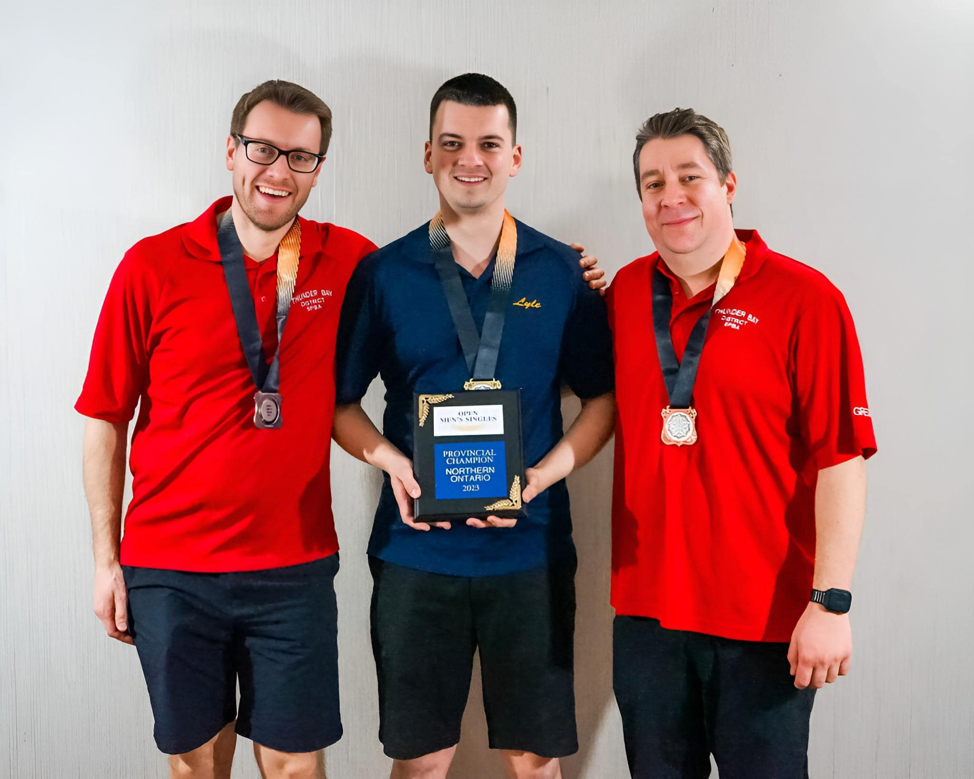
Silver Medallist – Wesley Swoluk | Gold Medallist – Lyle Dolph | Bronze Medallist – Greg DeGrazia
THUNDER BAY | NICKEL DISTRICT | THUNDER BAY

At the 2023 C5PBA Nationals in Edmonton, Lyle placed 6th in the 21-game qualifying round missing the stepladder finals by 85 pins.

PREVIOUS MENS SINGLES PROVINCIAL CHAMPIONS
1979 | Cliff Keenan | THUNDER BAY
1980 | Romauno Taus | NICKEL DISTRICT
1981 | Ron Stansfield | LAKE OF THE WOODS | NATIONAL BRONZE MEDALLIST
1982 | Dennis Umakoshi | THUNDER BAY
1983 | Ron Stansfield | LAKE OF THE WOODS
1984 | Alex Boyle | NICKEL DISTRICT
1985 | Alex Boyle | NICKEL DISTRICT | NATIONAL ALL-STAR
1986 | Stan Sutor | THUNDER BAY
1987 | Dale Jensson | SUNSET COUNTRY
1988 | Don Malette | CAMBRIAN NORTH | NATIONAL SILVER MEDALLIST
1989 | Dan Robson | NICKEL DISTRICT
1990 | Jean Bisson | NICKEL DISTRICT
1991 | Ron Stansfield | SUNSET COUNTRY
1992 | Kevin Freeland | CAMBRIAN NORTH
1993 | John Burla Jr. | THUNDER BAY
1994 | Marc Branning | CAMBRIAN NORTH
1995 | Dan Robson | NICKEL DISTRICT
1996 | Kevin Freeland | CAMBRIAN NORTH
1997 | Ray Parisotto | NICKEL DISTRICT
1998 | Mike McNamara | NICKEL DISTRICT | NATIONAL BRONZE MEDALLIST
1999 | Kevin Blake | SUNSET COUNTRY
2000 | Dennis Umakoshi | NORTH OF SUPERIOR
2001 | Stewart Laughton | NORTH OF SUPERIOR
2002 | Richard Peltola | NORTH OF SUPERIOR
2003 | Darryl Rollins | SUNSET COUNTRY
2004 | Dennis Umakoshi | NORTH OF SUPERIOR
2005 | Rene Godin | CAMBRIAN NORTH | NATIONAL BRONZE MEDALLIST
2006 | Kevin Blake | SUNSET COUNTRY
2007 | Rene Godin | CAMBRIAN NORTH | NATIONAL BRONZE MEDALLIST
2008 | Kevin Freeland | CAMBRIAN NORTH
2009 | Chad Gagnon | NICKEL DISTRICT
2010 | Greg DeGrazia | THUNDER BAY | NATIONAL GOLD MEDALLIST AND ALL-STAR
2011 | Kevin Freeland | CAMBRIAN NORTH
2012 | Jeff Watts | SUNSET COUNTRY | HAD HIGH GAME OF NATIONALS OF 408
2013 | Greg DeGrazia | THUNDER BAY | HAD HIGH GAME OF NATIONALS OF 410
2014 | Jason Remmerswaal | NICKEL DISTRICT
2015 | Greg DeGrazia | THUNDER BAY | NATIONAL GOLD MEDALLIST AND ALL-STAR
2016 | Kevin Freeland | CAMBRIAN NORTH
2017 | Darryl Gauthier | GOLD BELT
2018 | Jeff Watts | SUNSET COUNTRY
2019 | Patrick Perrin | GATEWAY
2022 | Greg DeGrazia | THUNDER BAY | NATIONAL BRONZE MEDALLIST AND ALL-STAR
2023 | Lyle Dolph | NICKEL DISTRICT

MENS SINGLES – PROVINCIAL RECORD SCORES
HIGH SINGLE | Dan Taylor | THUNDER BAY | 2016 | 450
HIGH FIVE | Rod Smith | CAMBRIAN NORTH | 1998 | 1554
HIGH TEN | Mike McNamara | NICKEL DISTRICT | 1998 | 2976

