2023 MENS TEAM PROVINCIAL CHAMPIONS

THUNDER BAY
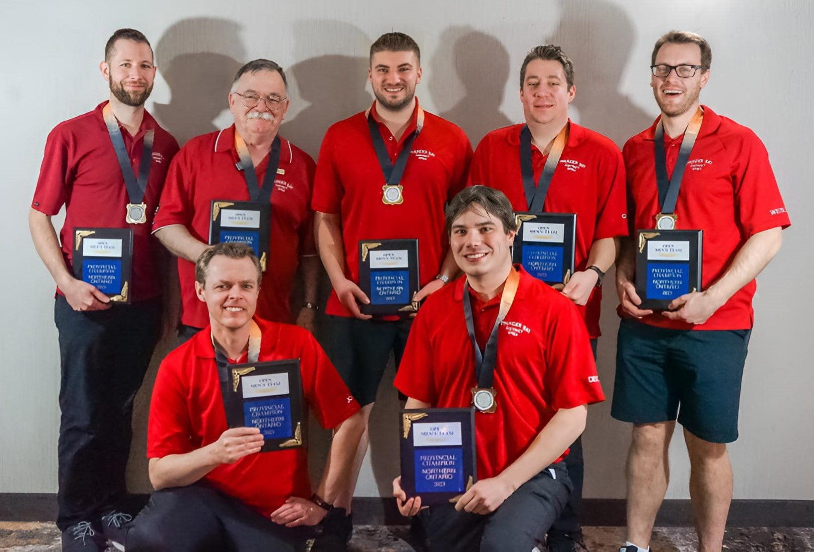
Back Row from Left-to-Right: Neil Felbel, Bob Taylor (coach), Adam Goose, Greg DeGrazia, Wesley Swoluk
Front Row from Left-to-Right: John Willcott, Devin Klassen

At the 2023 C5PBA Nationals in Edmonton, the mens team averaged a blistering 273 as a team but ended up finishing in a tie for 5th place, one point out of the stepladder finals. John Willcott was named to the all-star team with his incredible performance of averaging 292.27 and winning 14 of 18 matches.

At the provincials in North Bay, Lyle Dolph of Nickel District set a provincial record of 4600 for the 15-game provincial team qualifying round (a 306.7 average), eclipsing the mark of 4537 by Mauno Taus in 1985.

PREVIOUS MENS TEAM PROVINCIAL CHAMPIONS
1979 – THUNDER BAY
Walter Belanger, Brad Didyk, Cliff Keenan, Quentin Snider, Domenic Bet, Bryan Chiupka, John DeGrazia (coach)
1980 – NICKEL DISTRICT
Mauno Taus, Don Riopel, Jim Blea, Wayne Roy, Arnie Rollins, Lou Parisotto, Ray Parisotto (coach)
1981 – THUNDER BAY
Alex Jacobs, Frank Massaro, Domenic Bet, Bryan Chiupka, Vince Lombardo, Ivan Nichols, Armand Compardo (coach)
1982 – NICKEL DISTRICT
Sam Freeland, Denis Robert, Don Riopel, Dave Kennedy, Bruno Blasutti, Mario Bigolin, Rod Smith (coach)
1983 – NICKEL DISTRICT
Greg Beaucage, Glenn Smith, Roger Levesque, Don Riopel, Dave Kennedy, Henry Beaudry, Denis Robert (coach)
1984 – THUNDER BAY
Cliff Keenan, Dennis Umakoshi*, Alex Jacobs, Kevin Keenan, Bryan Chiupka, Aldo Dezan, Rudy Sproveri (coach)
1985 – NICKEL DISTRICT – NATIONAL SILVER MEDALLISTS
Kevin Freeland, Alex Boyle*, George May, Mauno Taus, Noah Bertuzzi, Bob Sproule, Tauno Saari (coach)
1986 – THUNDER BAY
Ivan Nichols, Stan Sutor, Vince Lombardo, Dennis Umakoshi*, John Pellizzari, Larry Perepeluk, Dave Burla (coach)
1987 – CAMBRIAN NORTH – NATIONAL SILVER MEDALLISTS
Greg Beaucage, Jim MacLellan, Terry Branning, Don Malette, Clem Godin, Martial Lemoyne, Claude Rheaume (coach)
1988 – THUNDER BAY
Cliff Keenan, Norman Randle, Larry Bertin, Stan Sutor, Gar Honkey, Vince Lombardo, Reuben McFarland (coach)
1989 – NICKEL DISTRICT
Wayne O’Sullivan, David Secord, Dan Robson, Pat McNamara, Jean Bisson, Mike Taus, Graham Squirell (coach)
1990 – THUNDER BAY
Luigi Renzi, Michael Sprague, Boyd Wayde, Dennis Umakoshi*, Vince Lombardo, Philip Belle, Rudy Mauro (coach)
1991 – CAMBRIAN NORTH
Don Malette, Jim MacLellan, Hub Frappier, Kevin Freeland, Louis Leduc, Sam Freeland, Roger Cardinal (coach)
1992 – GATEWAY
George Greenside, Carmen Stoddart, Phil Smith, Rheal Lagrandeur, Ray Arcand, Gerry Lamarche, Hugh Cosgrove (coach)
1993 – CAMBRIAN NORTH
Don Malette, Marc Branning, Bill Belleville, Barry Stevens, Hub Frappier, Kevin Freeland, Carmen Champagne (coach)
1994 – CAMBRIAN NORTH
Rob Sousek, Marc Branning, Jerome Lesny, Kevin Freeland, Don Malette, Martial Lemoyne, Roger Cardinal (coach)
1995 – GOLD BELT
Emile Murray, Wayne Kingsbury, Leonard Leveille, Ed Gagne, Brad Bacvar, Eric Brazeau, George Brazeau (coach)
1996 – CAMBRIAN NORTH
Kevin Freeland, Don Malette, Denis Giroux, Marc Branning, Bill Belleville, Darcy Brazeau, Jerome Lesny (coach)
1997 – CAMBRIAN NORTH
Kevin Freeland, Barry Stevens, Brian Gagnon, Rene Godin, Don Riopel, Troy Raymond, Roger Cardinal (coach)
1998 – NICKEL DISTRICT – NATIONAL BRONZE MEDALLISTS
Dave Secord, Mike McNamara, Pete Blanchard, Jean-Marie Girard, Dan Lefebvre, Phil Desaulnier, Jim MacLellan (coach)
1999 – CAMBRIAN NORTH – NATIONAL GOLD MEDALLISTS
Kevin Freeland, Barry Stevens, Robert Cardinal*, Rob Sousek, Don Brabant, Don Riopel*, Jack Atkinson¹ (coach)
2000 – NICKEL DISTRICT
Mike McNamara, David Secord, Rob Sousek, Jean-Marie Girard, Todd Innis, Guy Meilleur, Jim MacLellan (coach)
2001 – GATEWAY
Tom Williams, James McKenny, Kevin Mantha, Bert Rachar, Chris Bissonette, Mike Gauthier, Hugh Cosgrove (coach)
2002 – NICKEL DISTRICT
Rob Parisotto*, David Secord, Mike McNamara, Pete Blanchard, Jean-Marie Girard, Dan Lefebvre, Jim MacLellan (coach)

PREVIOUS MENS TEAM PROVINCIAL CHAMPIONS
2003 – NORTH OF SUPERIOR
John Burla Jr., Darren Bailey, Stewart Laughton, David Ford, John DeGrazia, Richard Peltola, Dave Burla (coach)
2004 – CAMBRIAN NORTH
Darryl Vachon, Kevin Champagne, Rob Cardinal, Patrick Hauser, Don Brabant, Barry Stevens, Roger Cardinal (coach)
2005 – CAMBRIAN NORTH
Kevin Freeland, Rene Godin, Jason Medhurst, Tom Williams, Don Gagnon, Chad Gagnon, Ed Bernier (coach)
2006 – NICKEL DISTRICT – NATIONAL BRONZE MEDALLISTS
Pete Blanchard, Guy Meilleur, Rob Parisotto, Chad Gagnon, Mike McNamara, Eric Lemieux, Jim MacLellan (coach)
2007 – NICKEL DISTRICT
Mike McNamara*, Jason Remmerswaal, Matthew Punkari, Pete Blanchard, Jean-Marie Girard, Rob Parisotto, Jim MacLellan (coach)
2008 – NICKEL DISTRICT
Pete Blanchard, Mike McNamara, Mike Garbutt, Rob Parisotto, David Secord, Eric Lemieux, Bill Mitchell (coach)
2009 – SUNSET COUNTRY
Chris Gadd, Darryl Rollins, Andrew Stamarski, Kevin Blake, Roger Peterson, Ric Kitzul, Arnie Rollins (coach)
2010 – CAMBRIAN NORTH
Kevin Freeland, Tom Williams, Brian Gagnon, Barry Stevens, Rick Tasse, Rene Godin, Donna Stevens (coach)
2011 – THUNDER BAY
Greg DeGrazia, Kyle Goose, Matt McLean, John DeGrazia, Aaron Zewiec, Gene Prpic, Bob Taylor (coach)
2012 – THUNDER BAY
Greg DeGrazia, Kyle Goose, Rob Sousek, John DeGrazia, Glenn Ford, Dan Taylor, Joanne Walters (coach)
2013 – THUNDER BAY
Greg DeGrazia, Dwayne Smith, Matt Shonosky*, Allan Hurst, Wesley Swoluk, Dan Taylor, Bob Taylor (coach)
2014 – THUNDER BAY
Greg DeGrazia, Devin Klassen, Taylor Michel, Dan Taylor, Allan Hurst, Wesley Swoluk, Bob Taylor (coach)
2015 – THUNDER BAY – NATIONAL SILVER MEDALLISTS
Trevor Cava, Dan Taylor, Greg DeGrazia*, Allan Hurst, Adam Goose, Taylor Michel, Bob Taylor (coach)
2016 – THUNDER BAY – NATIONAL BRONZE MEDALLITS
Wesley Swoluk*, Dan Taylor, Adam Goose, Kyle Goose, Greg DeGrazia, Taylor Michel, Bob Taylor (coach)
2017 – THUNDER BAY
Greg DeGrazia, Dan Taylor, Matt Shonosky, Taylor Michel, Allan Hurst, Wesley Swoluk, Phil Belle (coach)
2018 – THUNDER BAY – NATIONAL BRONZE MEDALLISTS
Taylor Michel*, Wesley Swoluk, Dan Taylor, Greg DeGrazia, John Willcott, Tyson Nelson, Bob Taylor (coach)
2019 – THUNDER BAY – NATIONAL BRONZE MEDALLISTS
Taylor Michel*, Greg DeGrazia*, Philip Mayo, John Willcott, Neil Felbel, Aaron Frade, Bob Taylor (coach)
2022 – THUNDER BAY – NATIONAL SILVER MEDALLISTS
Taylor Michel*, Greg DeGrazia*, Devin Klassen, Philip Mayo, Wesley Swoluk, Matt Shonosky, Bob Taylor (coach)
2023 – THUNDER BAY
Greg DeGrazia, Devin Klassen, Wesley Swoluk, Adam Goose, Neil Felbel, John Willcott*, Bob Taylor (coach)
* – National All-Star 1 – Replaced by Jim MacLellan at Nationals

MENS TEAM – PROVINCIAL RECORD SCORES - INDIVIDUAL
HIGH SINGLE | Greg DeGrazia | THUNDER BAY | 2012 | 433
HIGH FIFTEEN | Lyle Dolph | NICKEL DISTRICT | 2023 | 4600 *NEW RECORD*

MENS TEAM – PROVINCIAL RECORD SCORES – TEAM
HIGH SINGLE | GOLD BELT | 2018 | 1576
HIGH FIFTEEN | THUNDER BAY | 2018 | 19921
HIGH POINTS | THUNDER BAY | 2022 | 94

