2023 MIXED TEAM PROVINCIAL CHAMPIONS

THUNDER BAY
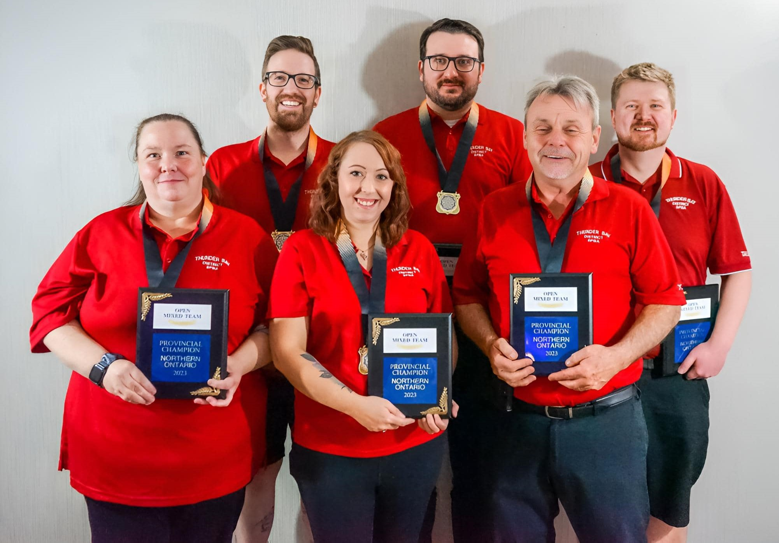
Back Row from Left-To-Right: Dave Laframboise, Matt Shonosky, Taylor Michel
Front Row from Left-To-Right: Linda Baccari, Rylee Baturniak, Doug Glena (coach)

At the 2023 C5PBA Nationals in Edmonton, the mixed team finished in 7th place, 13 points out of a playoff spot. Taylor Michel was named to the all-star team by averaging a staggering 298.95 for the tournament, winning 15 of 20 matches and throwing two 400s (420 and 415).

PREVIOUS MIXED TEAM PROVINCIAL CHAMPIONS
1979 – NICKEL DISTRICT – NATIONAL GOLD MEDALLISTS
Germaine Winch, Freda Beaucage, Ev McNamara, Frank Gramolini, Don Riopel, Moe Chaumount, Pat McNamara*, John Punkari (coach)
1980 – THUNDER BAY
Ada Becotte, Susan Ball, Julie Biley, Ivan Nichols, Alf Lovis, Domenic Bet, Rick Malcolm, Ruth Lee (coach)
1981 – THUNDER BAY – NATIONAL GOLD MEDALLISTS
Alice Compardo, Wendy Prouty, Susan Ball, Bob Taylor, Tom Anderson*, Cliff Keenan, Tom Anderson, Gary Beyko (coach)
1982 – NICKEL DISTRICT – NATIONAL GOLD MEDALLISTS
Gillian Bromley, Dorothy Malott, Vi Roy, Art Carbone¹, Don Malette, Alex Boyle, Wayne Roy, Arnie Rollins (coach)
1983 – NICKEL DISTRICT
Marion Heikkala, Lorrie Milsap, Jacqueline Dunsford, Kevin Freeland, Ralph Bromley, Alex Boyle, Wayne Roy, Arnie Rollins (coach)
1984 – THUNDER BAY
Elvira Dustin, Eunice Hill, Carole Minchin, Larry Perepeluk, Gordon Restrick, Garfield Honkey, Stewart Laughton, Dave Burla (coach)
1985 – CAMBRIAN NORTH
Fran Legault, Germaine Winch, Vi Roy, Bill French, Urgel Rheaume, Bill Bodycott, John Giroux, Sam Freeland (coach)
1986 – CAMBRIAN NORTH
Vi Roy, Carol Wicklander, Debbie Freeland, Rick Laberge, Don Riopel, Rick Rancourt, Arnie Rollins, Sam Freeland (coach)
1987 – THUNDER BAY
Sherri Randle, Lois Buckley, Debbie McDonald, Brian Adams, Bob Taylor, Michael Sprague, Aldo Dezan, Frank Massaro (coach)
1988 – THUNDER BAY
Donna Hryenchuk, Carol Minchin, Debbie Rivers, Ivan Nichols, Joe Boesch, Dennis Umakoshi*, Art Illka, Larry Perepeluk (coach)
1989 – NICKEL DISTRICT – NATIONAL BRONZE MEDALLISTS
Louise Cormier, Carole Kolisnek, Pauline Lacelle, Alex Boyle, Jack Atkinson, Allan Lapensee, Ron Boreham, Alex Jacobs (coach)
1990 – THUNDER BAY – NATIONAL BRONZE MEDALLISTS
Sharon Zaborniak, Pat Connelly, Hazel Eccleston, Bob Taylor Rob Sousek, Bryan Chiupka², Karlo Beecken, Reuben McPharland (coach)
1991 – NICKEL DISTRICT
Denise Cardinal, Sherry Jolette, Marguerite Laderoute, Urgel Rheaume, Dave Secord, John Giroux, Allan Lapensee, Jack Atkinson (coach)
1992 – CAMBRIAN NORTH
Gisele Venne, Helene Duval, Doris Kirkey, Jim MacLellan, Wayne O’Sullivan, Barry Stevens, John Needs, Roger Cardinal (coach)
1993 – NICKEL DISTRICT
Kay Van Norman, Susan Hines, Lisette Lalande, Dan Robson, Tim Weatherley, Allan Lapensee, Rick Weatherley, Barry Gagnon (coach)
1994 – CAMBRIAN NORTH
Deborah Freeland, Helene Duval, Desnieges Vallee, Brian Gagnon, Clark Caverley, Claude Rheaume, Gilles Barbe, Ray Marlok (coach)
1995 – CAMBRIAN NORTH
Chris Godin, Monique L’Heureux, Gislaine Bruyere, Barry Stevens, John Giroux, Don Malette, Don Riopel, Ray Marlok (coach)
1996 – THUNDER BAY
Ruby Lynch, Debbie Keating, Vicki Slater, John Burla Jr., Philip Belle, Gene Prpic, John Pellizzari, Brian Adams (coach)
1997 – CAMBRIAN NORTH
Barbra McLachlan, Pamela Lepage, Sara Horner, Reg Michaud, Garnet MacGarvie, Donald Brabant, Daniel Rheaume, Bill McLachlan (coach)
1998 – CAMBRIAN NORTH
Denise Blake, Jennifer Raymond, Sara Horner, Stephane Loranger, Don Gagnon, Denis Giroux, Gerry Vachon, Milly Rothwell (coach)
1999 – NORTH OF SUPERIOR
Sherri Honkey, Wendy Kurylyk, Donna Hryenchuk, Gene Prpic, Alan Morais, Richard Peltola, Darren Bailey, Janice Sopko-Elllingson (coach)
2000 – GOLD BELT
Huguette Cloutier, Bridgitte Dulac, Lori Graham, Brian Kenny, Darcy Brazeau, Brad Bacvar, Dan Gervais, Claude Belanger (coach)
2001 – CAMBRIAN NORTH
Jennifer Raymond, Coco Lariviere, Maureen McKay, Robert Cardinal, Neil Rothwell, Rene Godin, Patrick Rheaume, Jack Atkinson (coach)
2002 – NICKEL DISTRICT
Kelly McNamara, Jen Chamberland, Pauline Stables, Rob Sousek, Phil Desaulnier, Urgel Rheaume, Guy Meilleur, Barry Gagnon (coach)
2003 – GOLD BELT
Diane Migneault, Marie Cloutier, Fleurette Gamache, Robert Gamache, Maurice Desjardines, Ron Paquette, Jeannine Horner (coach)
2004 – NICKEL DISTRICT
Sherry Jolette, Maija Holla, Kerri-Lynn Moxam, Richard Gauthier, Rob Parisotto, Phil Desaulnier, Francis Innis (coach)
PREVIOUS MIXED TEAM PROVINCIAL CHAMPIONS
2005 – NICKEL DISTRICT
Kelly McNamara, Cindy Lalonde, Shawna Gauthier, Barry Gagnon, Pete Blanchard, Phil Desaulnier, Richard Gauthier (coach)
2006 – NORTH OF SUPERIOR
Susan Vignuda, Sarah Umakoshi, Tammy Walchuk, Richard Peltola, Rob Kucher, Alan Morais, Bob Taylor (coach)
2007 – CAMBRIAN NORTH
Donna Stevens, Doris Kirkey, Lynda Presse, Barry Stevens, Jon Wood, Troy Raymond, Charles Gobeil (coach)
2008 – CAMBRIAN NORTH
Shannon Swerdlyk, Doris Kirkey, Lynda Presse, Roger Givoque, Rick Cutler, Charles Gobeil, Donna Stevens (coach)
2009 – GATEWAY
Angele Penasse, Shirley Arbour, Jennifer Alford, Scott McDonald, James Restoule, Jonathan Rivard, Hugh Cosgrove (coach)
2010 – GATEWAY
Nicole Legault, Joanne Webster, Debbie Ruck, Johnathan Rivard, Barry Tremblay, Robert Drouin, Hugh Cosgrove (coach)
2011 – CAMBRIAN NORTH
Lynn Dominelli, Lynn Imbeau, Monique L’Heureux, J.R. Belisle, Rick Tasse, Moe Beaudoin, Lise Anderson (coach)
2012 – THUNDER BAY
Kelsey Belluz, Devan Hook, Codi Glena, Neil Felbel, Wesley Swoluk, Josh Pellizzari, Janice Sopko-Ellingson (coach)
2013 – CAMBRIAN NORTH
Doris Kirkey, Lynn Dominelli, Lise St. Denis, Huntley Brown, Ryan McGarry, Don Gagnon, Moe Beaudoin (coach)
2014 – GOLD BELT
Melanie Paquette, Louise Quirion, Rhonda Little, Chad Ryan, Darryll Belanger, Shawn Nugent, Claude Belanger (coach)
2015 – THUNDER BAY
Codi Glena-Michel, Krysten Cripps, Angela Begin, Neil Felbel, Wesley Swoluk, Oleg Lozynsky, Joanne Walters (coach)
2016 – THUNDER BAY
Devan Hook, Kirstynn Taniwa, Codi Glena-Michel, Trevor Cava, Dwayne Smith, Neil Felbel, Doug Glena (coach)
2017 – THUNDER BAY
Amanda Nichols, Kirstynn Taniwa, Codi Glena-Michel, Trevor Cava, Rob Aiken, David Laframboise, Ron Melanson (coach)
2018 – NICKEL DISTRICT
Lise St. Denis, Diane Depatie, Pauline Stables, Jason Remmerswaal, Richard Gauthier, Urgel Rheaume, Lynn Imbeau (coach)
2019 – THUNDER BAY
Devan Hook, Kirstynn Taniwa, Codi Glena-Michel, Parker Sdao-Compardo, Kyle Bonnie, Quentin Snider Sr., Doug Glena (coach)
2022 – THUNDER BAY
Ashley Baccari, Codi Michel, Angela Begin, Adam Goose, John Willcott, Neil Felbel, Doug Glena (coach)
2023 – THUNDER BAY
Linda Baccari, Rylee Baturniak, Matt Shonosky, Taylor Michel*, Dave Laframboise, Doug Glena (coach)
* – National All-Star 1 – Replaced by Roger Levesque at Nationals 2 – Replaced by Frank Massaro at Nationals

MIXED TEAM – PROVINCIAL RECORD SCORES – INDIVIDUAL - LADIES
HIGH SINGLE | Linda Ryan | GOLD BELT | 2001 | 410
HIGH FIFTEEN | Barbra McLachlan | CAMBRIAN NORTH | 1997 | 3714

MIXED TEAM – PROVINCIAL RECORD SCORES – INDIVIDUAL - MEN
HIGH SINGLE | Placide Dubois | GATEWAY | 1983 | 435
HIGH FIFTEEN | Pete Blanchard | NICKEL DISTRICT | 2005 | 4265

MIXED TEAM – PROVINCIAL RECORD SCORES – TEAM
HIGH SINGLE | THUNDER BAY | 2012 | 1500
HIGH FIFTEEN | THUNDER BAY | 2006 | 18155
HIGH POINTS | THUNDER BAY | 2012 | 96

